“Coaches Corner” Content

Here is the link to the coaching clinic video from last year

https://www.youtube.com/watch?v=mFQBqqZG11M&feature=youtu.be
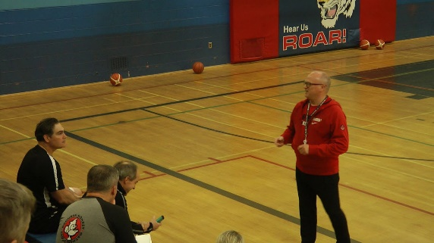 | Coaching Presentation  www.youtube.com  Coaching the Coaches

