Movement in Movement Prep |  |  |  | 
Danielle Dobney did an outstanding dynamic warm up at our Age Group Assessment Camp. Here are some ways I have modified the concepts she was using. One thing we have found with our athletes is if you continue to do the same thing over and over in warm up, they get bored and lose focus. By adding in some variety it keeps it fresh. As long as the principles of a good warm up are in place this is fine.
Agility work
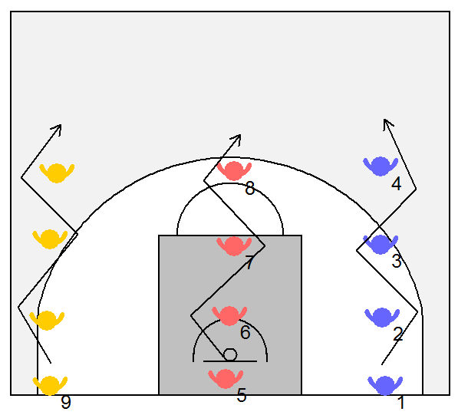  Starting positions | The players line up in lines as shown in the diagram to the right. They run forward weaving between the players in front. When reaching the end the the player stops in the front of the line. The last player in the line now goes. The players progress down the court. |  | 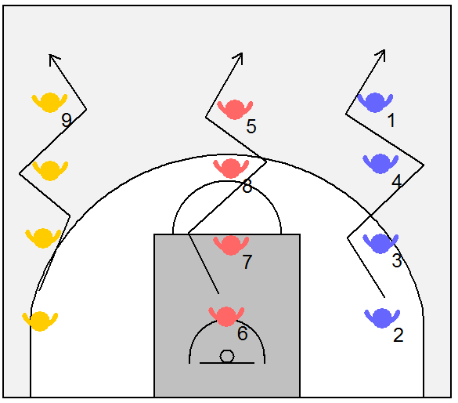
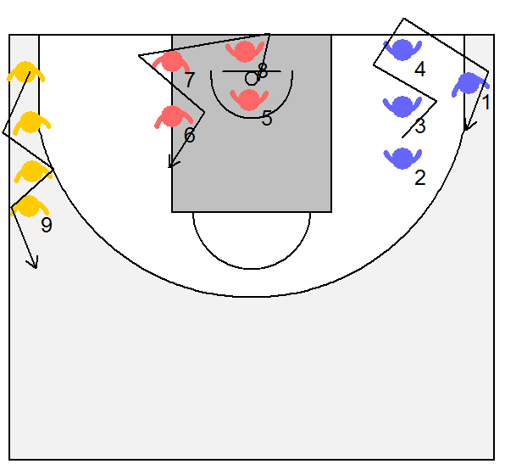  Turning | When reaching the far end or the turning line the players just start back the other way.  Some modifcations I have used:  - Make it a relay race ( watch out for cheaters)  - Add a ball  - Dribbling  - Handing it off  - The three players that are moving must stay in rhythm with one designated player. This player can go forward and backward, start and stop.
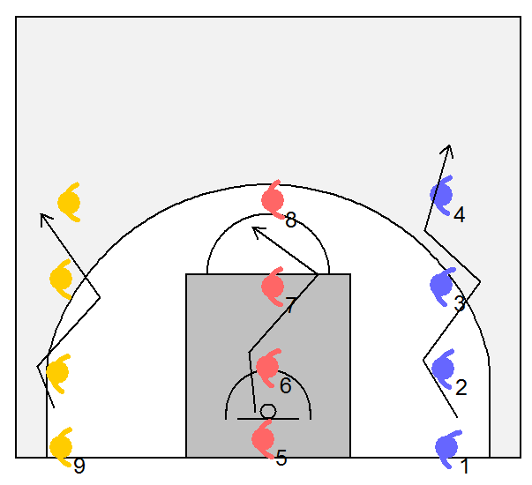  Moving sideways | 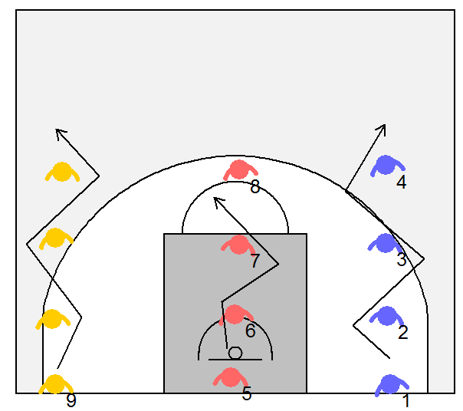  Moving backwards |  | 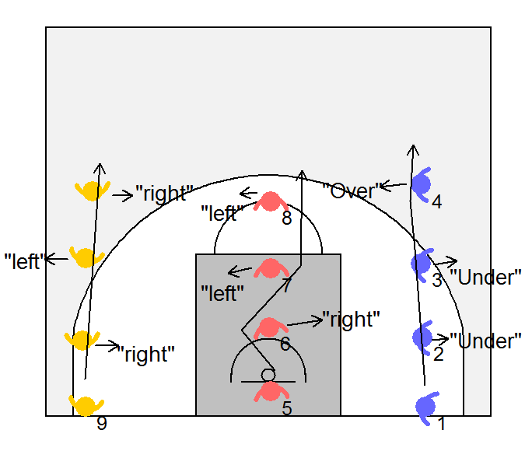  Talking
Talking
Running forward - The first line(yellow) - the player moving forward is tell the players in front which way to move one step side ways. We want random rather than a pattern. The player with the vision talks.

Running backwards – second line (red) – the players in the line are telling the player moving backward which way to move. The player with the vision talks.

Sideways – the players can work together calling over and under ( both have vision).

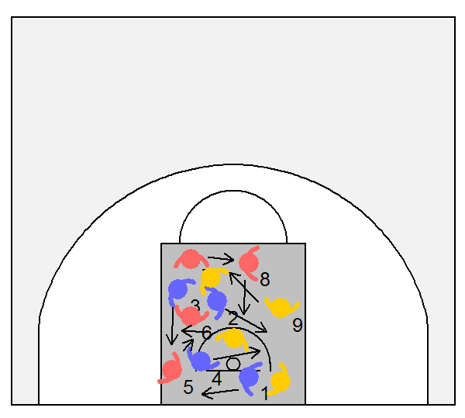 |  | This is by far my favorite drill. All the players are in the key. They are all moving at once trying to cover as much space as possible without leaving the key.  The object is not to run into the other players, but by shifting up and back and side to side make the contact minimal.  They should not stand up staright to avoid contact. Stay in an athletic stance. The arms are out protecting the feet.

